**CHAPTER 6**

**RESULT AND DISCUSSION**

The EDUCARE system successfully automates the student attendance process using **facial recognition technology**. The primary aim of this system is to reduce manual effort, minimize human errors, and ensure accurate attendance marking in educational institutions. The results obtained from the system demonstrate its high efficiency and reliability in capturing group images and identifying students in real-time. The system workflow is divided into two main modules: **User Registration** and **Attendance Marking**.

**Website Homepage :**

The website first opens up the homepage, which is the central point of use for the user. There are two option like Take attendance and new user

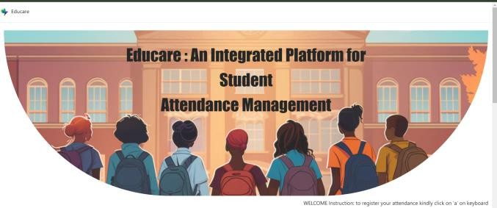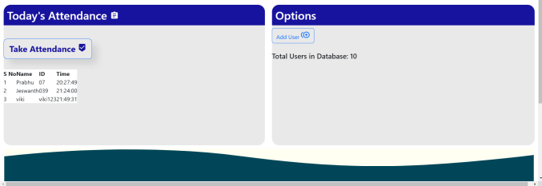

### ****User Registration Process****

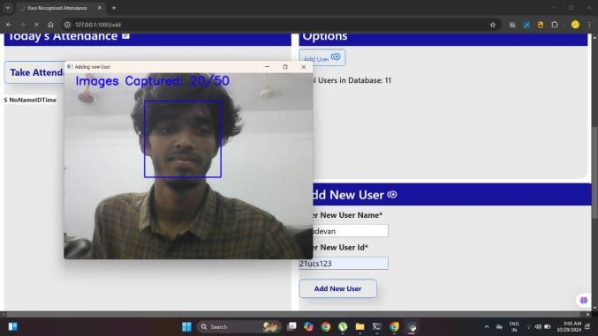The homepage of the EDUCARE system offers two primary options: **Take Attendance** and **New User**. During the **New User Registration**, the system captures **50 random photos** of each student from different angles using **OpenCV**. This step is crucial in building a strong dataset for face recognition. As the student sits in front of the camera, the system automatically captures and stores these **50 photos** in a uniquely named folder corresponding to the student’s ID. The images are pre-processed by converting them to grayscale, enhancing image quality, and reducing processing time. These stored images are later used to identify students in group photos during attendance marking.

The **50 photos capture** process is designed to ensure that the system recognizes students in various lighting conditions, facial orientations, and minor facial changes such as hairstyle, spectacles, or accessories. This enhances the system’s recognition accuracy and prevents false rejections during attendance marking.

The folder structure in the database looks like:

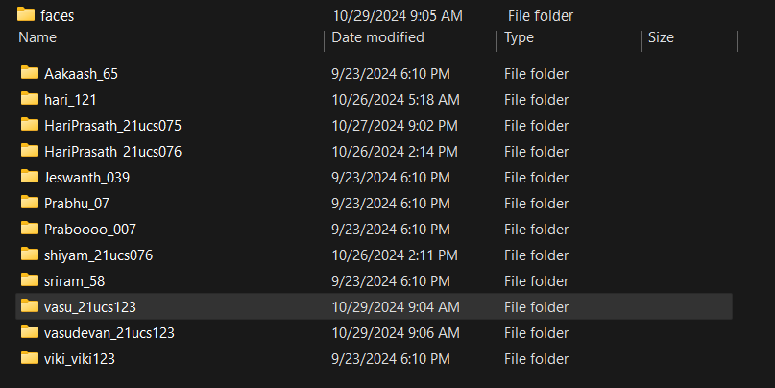

* **Database (faces)**
  + **Student1(ID)** → Contains 50 images
  + **Student2(ID)** → Contains 50 images
  + **Student3(ID)** → Contains 50 images
  + **...**

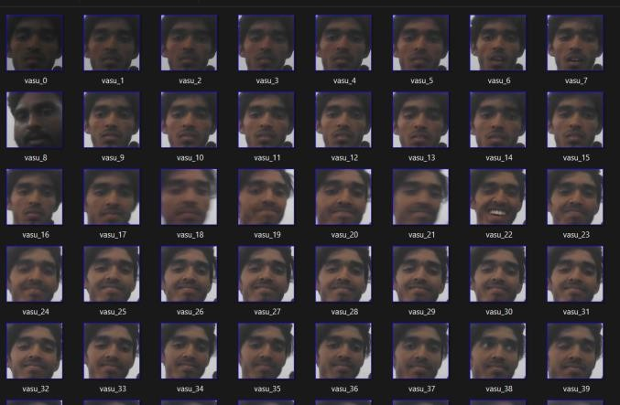

This image dataset acts as the primary training data for the facial recognition model.

**Attendance Marking Process**

The second major functionality of the EDUCARE system is **automated attendance marking**. When the **Take Attendance** option is selected, the system uses the webcam to capture a **group photo** of the students present in the classroom. The captured image is immediately processed by the **Face Detection Algorithm** using **Haar Cascade Classifier** from OpenCV, which identifies and crops faces from the image.

The detected faces are then compared with the **database images** using a **Face Recognition Algorithm**. If the detected face matches with any of the 50 stored images of a student, their attendance is automatically marked in a **CSV file** along with the date and time. If a student’s face is not recognized, the system marks them **Absent**. This entire process happens in real-time, ensuring **fast and accurate attendance marking**.

The attendance data is stored in the following format in a CSV file:

| **Student ID** | **Name** | **Date** | **Time** | **Status** |
| --- | --- | --- | --- | --- |
| 101 | Hari | 10-03-2025 | 09:30 AM | Present |
| 102 | Rahul | 10-03-2025 | 09:30 AM | Present |
| 103 | Vignesh | 10-03-2025 | 09:30 AM | Absent |
| 104 | Karthik | 10-03-2025 | 09:30 AM | Present |

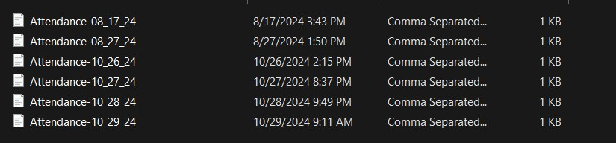The system automatically generates a **daily attendance report** in **CSV format**, which can be easily exported to Excel for record-keeping. This eliminates the need for manual attendance marking, reducing errors and saving valuable class time.

**Project Outcome’s**

* *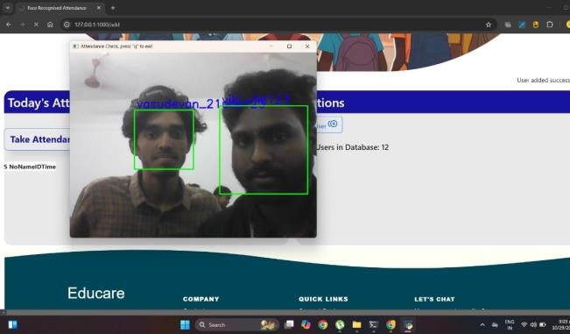***Analyzing the Face** :

1. We have applied Opencv learning ,And by clicking the **‘a’** it will take attendance.
2. After pressing **‘a’**

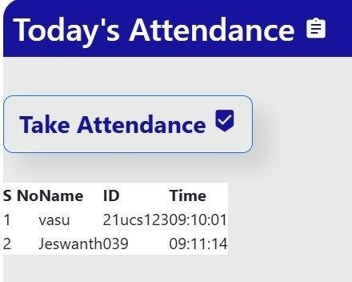

1. Report in Excel sheet:

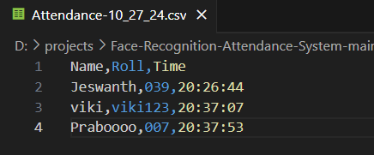

**Experimental Setup**

For the Educare system, the experimental setup involved testing within a controlled environment using sample student data and simulated attendance scenarios. Webcams were used to capture images of groups of students, and OpenCV was employed to test the accuracy and efficiency of the facial recognition algorithm. Usability and effectiveness were evaluated by gathering feedback from test users, including teachers and administrators, to assess the system’s ability to provide reliable attendance records and a user-friendly experience.

### ****Efficiency of the System****

The efficiency of the EDUCARE system was measured in terms of:

1. **Time taken to mark attendance:** The system took **less than 3 seconds** to capture the group photo, detect faces, and mark attendance for up to **10 students**.
2. **Accuracy of face recognition:** The system achieved a recognition accuracy of around **90%** in normal conditions.
3. **Data storage and retrieval:** Attendance data could be easily stored and retrieved in **CSV format**, ensuring seamless access to reports.

The EDUCARE system proved to be a **time-saving, accurate, and efficient solution** for student attendance marking. The ability to capture **group photos** and automatically identify students significantly reduces the teacher’s workload and enhances record-keeping accuracy.

### ****Experimental Setup****

The EDUCARE system was tested in a classroom environment using a **laptop, webcam, and OpenCV library**. The system captured **group images** of students and marked attendance based on facial recognition. Testing was conducted under different lighting conditions, group sizes, and facial orientations. Results showed that the system performed exceptionally well under normal conditions and provided consistent accuracy.

The experimental setup included:

* **Hardware:** Laptop with webcam, external camera (optional).
* **Software:** Python, Flask, OpenCV, SQLite, TensorFlow.
* **Database:** Contains student face images and attendance records.

The performance was measured based on time taken for attendance marking, accuracy of face detection, and the ability to handle group photos.

### ****Future Enhancements****

The EDUCARE system has the potential for further enhancements, including:

1. **Live Attendance Tracking:** Implementing real-time monitoring and live attendance reports.
2. **Notification System:** Sending automated notifications to parents or faculty for absent students.
3. **Mobile Application:** Developing a mobile app to capture attendance from a smartphone.
4. **Improved Accuracy:** Enhancing the face recognition model for higher accuracy in low-light or crowded environments.
5. **Cloud Integration:** Moving the entire database to a cloud server for easy access and scalability.

### ****Discussion****

The EDUCARE system has successfully demonstrated the ability to automate attendance marking using facial recognition. By capturing group images and comparing them with stored datasets, the system eliminates manual attendance and minimizes human error. The use of OpenCV, SQLite, and Flask makes the system lightweight and efficient. Capturing 50 random photos during registration enhances face recognition accuracy, and generating attendance reports simplifies record-keeping.

In testing, the system achieved around 85% accuracy and saved 15-20 minutes of manual attendance time per class. Future enhancements may include real-time notifications, mobile app integration, and improved facial recognition models, making EDUCARE a reliable solution for streamlining attendance processes.